**NAME- DEVANSHU SURANA**

**ELECTIVE ROLL NO-BT1-18**

**PANEL ROLL NO- PC-23**

**PRN-1032210755**

**PANEL-C**

**Experiment 6**

**BT**

**Problem Statement:**

Demonstrate setup of myEtherWallet and connect it to Ganache Network

**Aim:**

To demonstrate setup of myEtherWallet and connect it to Ganache Network

Theory:

MyEtherWallet:

i)MyEtherWallet is an open source, javascript, client-side tool for generating Ethererum Wallets & sending transactions.

ii)MyEtherWallet gives you the ability to generate new wallets so you can store your Ether yourself, not on an exchange.

iii)This process happens entirely on your computer, not our servers.

iv)Therefore, when you generate a new wallet, you are responsible for safely backing it up.

v)MyEtherWallet.com & MyEtherWallet CX are not “web wallets”.

vi)You do not create an account or give themyour Ether to hold onto.

vii)All data is created on our computer/your browser, not theirservers.

viii)It’s not a website where you put your Ether and theystore itfor you.

ix)They just make it easy for you to save your wallet information in your browser/on your computer.

x)Then they give you a place where you can access that information and do stuff with it.

Output:

1.Install MEW from https://github.com/MyEtherWallet/etherwallet/releases/tag/v3.21.06 . Find its index.html file and run it.

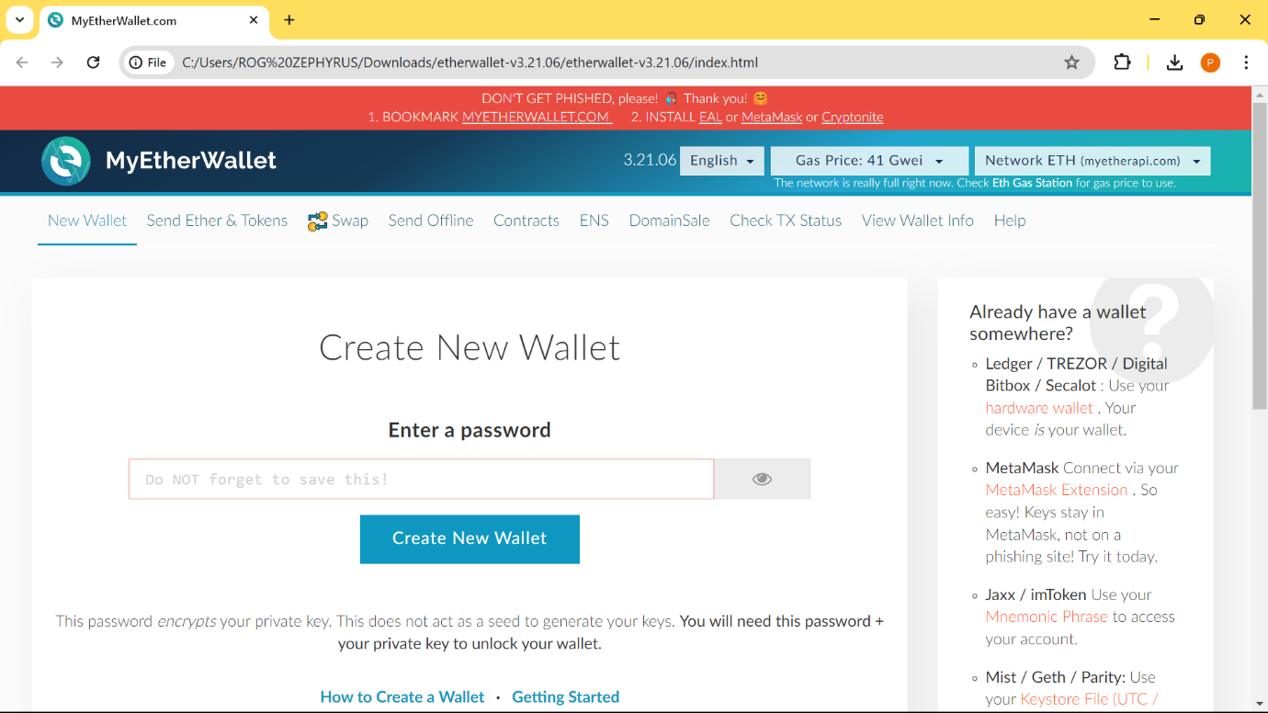

2.After running select Netowork by clicking on a drop-down located at top right corner and select option “Add Custom Network / Node”.

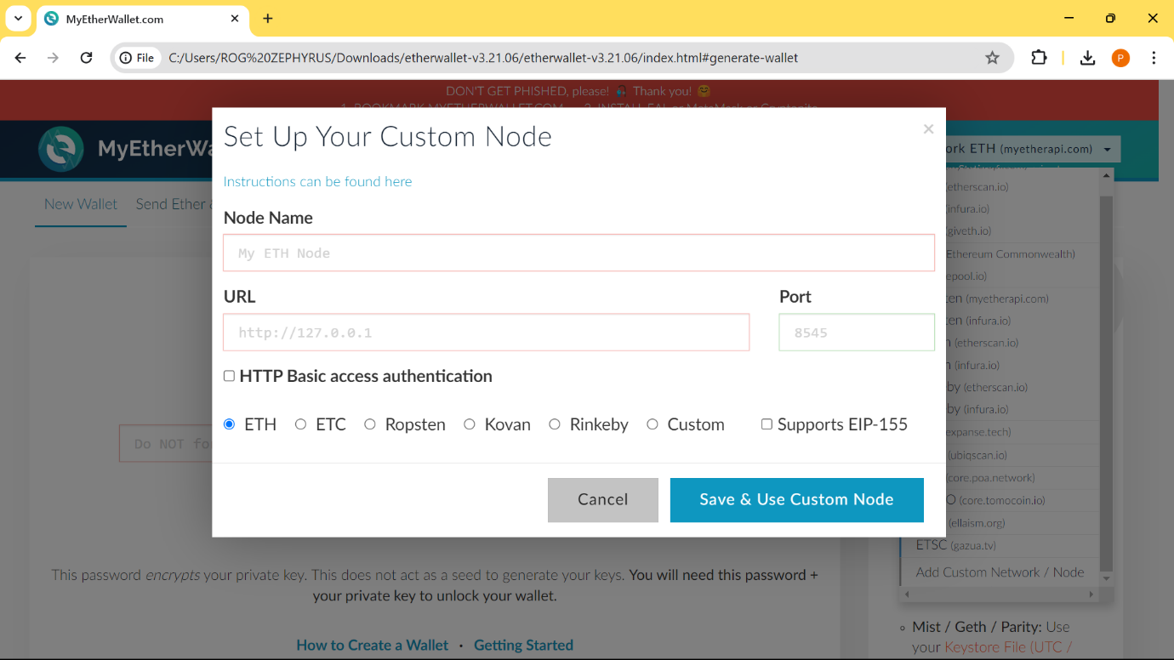

3.Now go to your Ganache Application and copy the “RPC Server” Address.

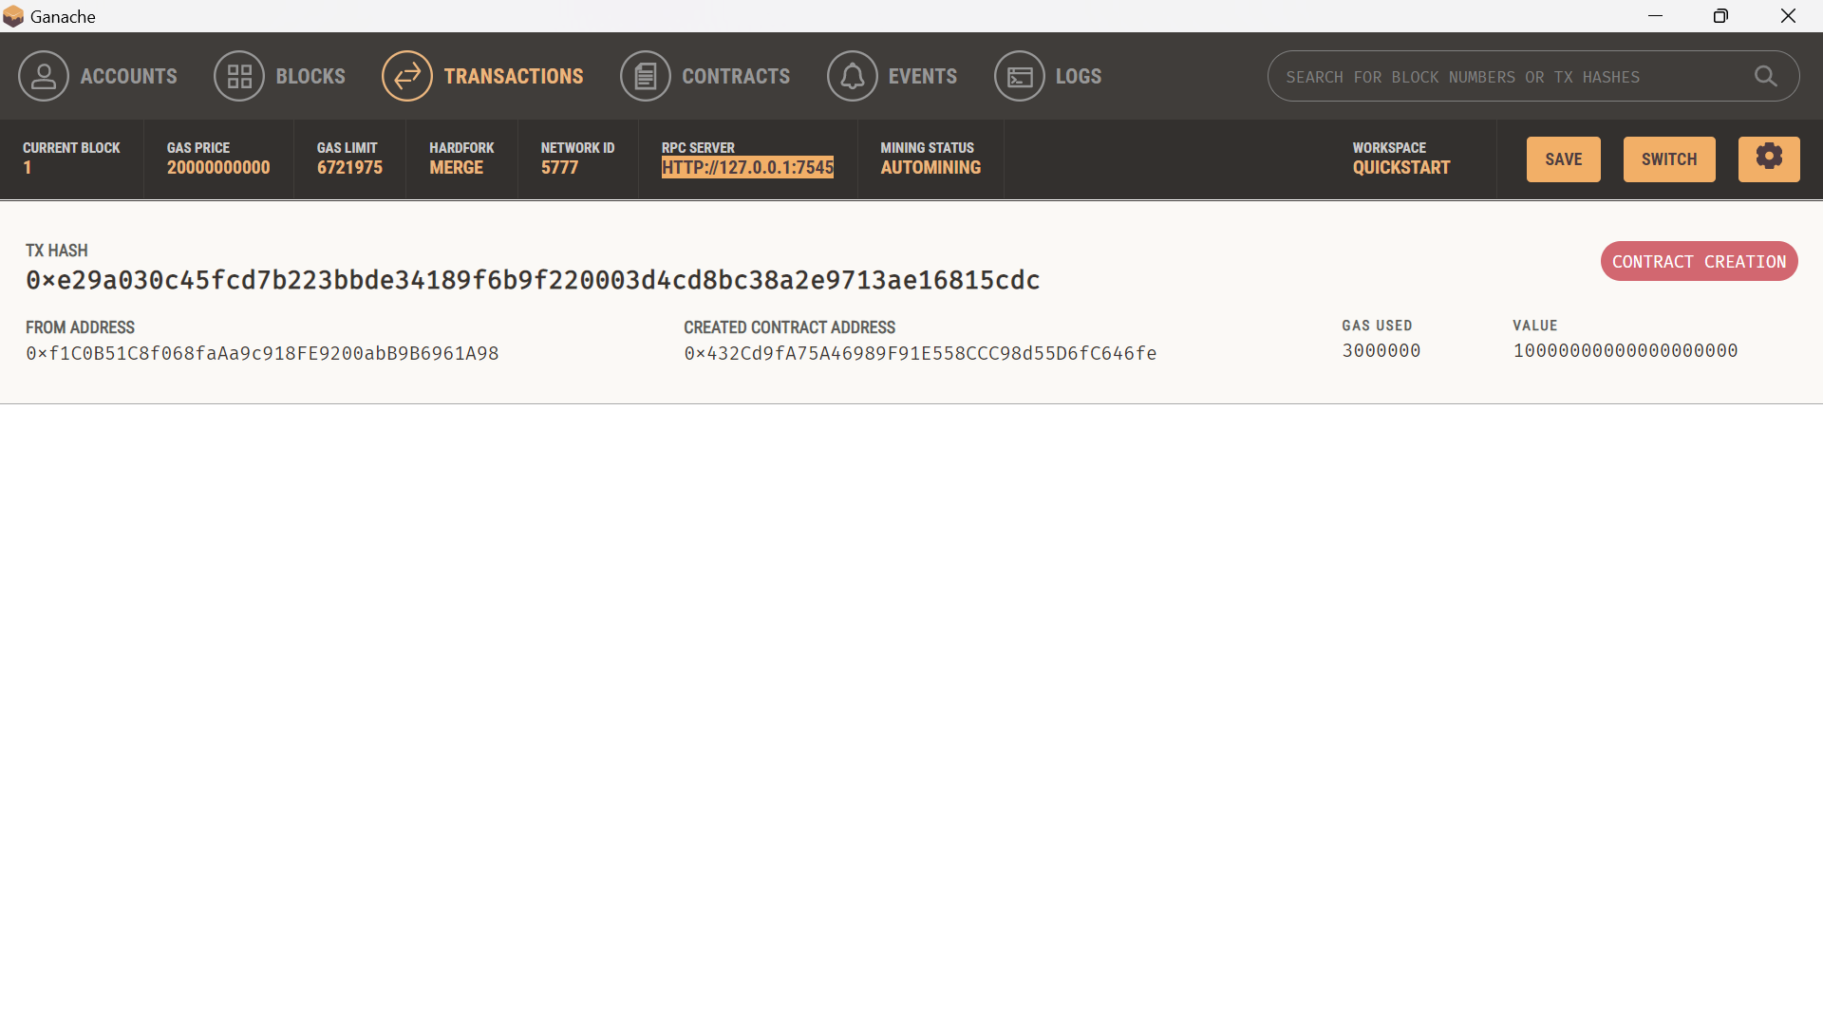

4.Set Node Name as give below and paste your RPC Address such that put numbers after colon(:) in the port. “Save & Use Custom Node”.

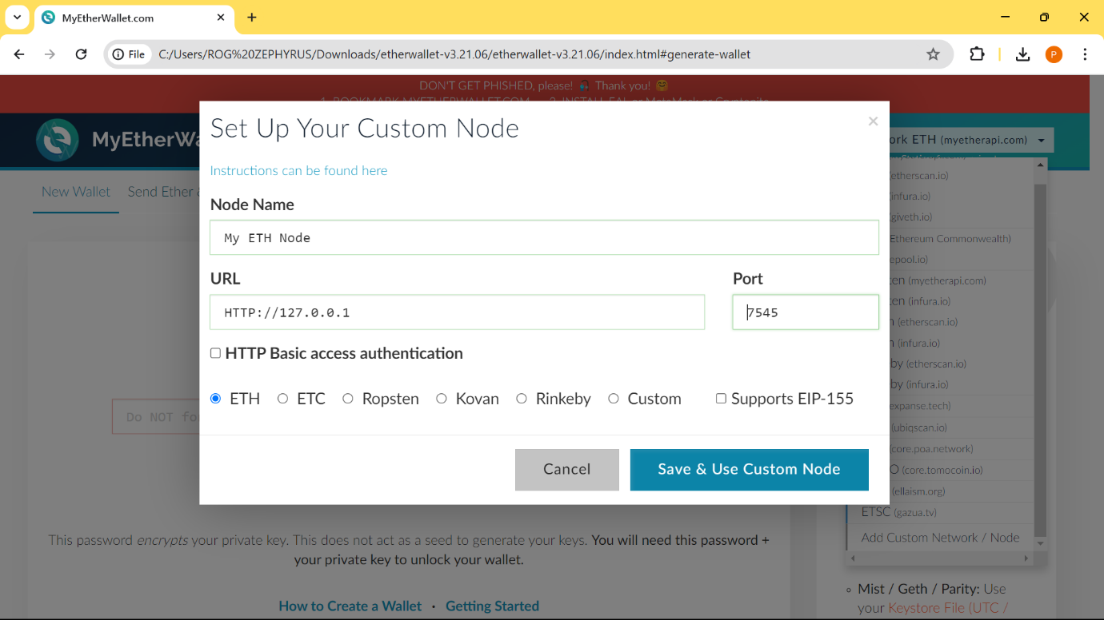

5.We have finally connected Ganache Network to MyEtherWallet.

